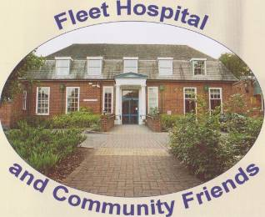
November 2018
Dear Friend,
This is the second of our twice-yearly newsletters from your Charity, giving you an update on our events and news from the hospital.
Its been a busy 6 months on all fronts, with news on the future of the hospital and new regulation requirement from the Charity Commission.
Hospital Site news.
There are projects under way to make the hospital, the new Hub for the Integrated Care Team, covering all the Fleet GP practices . This means that all Community services will be on site, together with Social Services, and mental health services. District nurses, midwives, Health visitors and others will all be able to hold joint meetings and plan multi -disciplinary discussion on patient care-planning. There will need to be building works to provide for this new initiative and funding has been confirmed. The Friends committee has been informed of all these developments and I’m sure there will be more news over the next few months.
I hear you all yelling “What about the car-parking”. We have continually voiced our concerns over this issue and the project leads have assured us that they are looking at several options to improve the provision. The local council and nearby surgery , are also on board to find a solution.
We are pleased with these new plans, as it goes some way to ensure the future of the site.
Charity Commission - new recommendations
Many thanks to all of you who returned your Data Protection forms. I will include further copies to the few of you that have not yet returned them. We have had several requests from members to ask if they can give their subs by standing order. We are happy to accept them by this route.
We have had to produce a Grant Making Policy and assessment form. This will help tracking requests and monitoring our donations are be used to good purpose.
We have had the good fortune in finding a new member who is going to help us keep the patients garden in good nick. There will be a problem with the coming building work, but his efforts will help greatly, in maintaining the area. Anyone who has time to give him a hand is very welcome to join the team of volunteers.
The street collection was again a success. Generating four new members and raising over £700 pounds. Thanks to all who helped on the day.
We do have a vacancy on the committee. New blood is needed to help us continue the work of your charity.
I would like to thank you all for your continued support, and wish you a Peaceful and
Happy Christmas.
Harrie Glossop RN
On behalf of the Committee and Trustees.

Dates for your diary
Christmas Fair November 24th at All Saints Community Hall 10am to 12am We would love to see any Friends who could attend, it would nice to meet our members.
Quiz February 8th at All Saint Hall, at 7.30pm. Anyone wanting to bring a team, please contact Chair Claire Pamment Tel No. 01252 615140
Email, harrieowen48@gmail.com
Web site -www.fhcf.co.uk

